Design Log

Cumberland Valley

C8

Wind Power

Viraj Singh and Reuben James

# 4.a.i: Materials

* Purchased Helicopter Blade
* CD
* CA Glue
* PLA Filament

**4.a.ii: Labeled Diagram**



**4.a.iii & 4.a.iv: Graphs & Data Tables**

| Out 15 cm | | |
| --- | --- | --- |
| Angle (degrees) | High Speed Voltage | Low Speed Voltage |
| 0 | 0.165 | 0.103 |
| 10 | 0.156 | 0.101 |
| 20 | 0.155 | 0.097 |
| 30 | 0.153 | 0.094 |
| 40 | 0.129 | 0.082 |
| 50 | 0.11 | 0.073 |
| 60 | 0.099 | 0.063 |
| 70 | 0.092 | 0.057 |
| 80 | 0.082 | 0.05 |
| 90 | 0 | 0 |

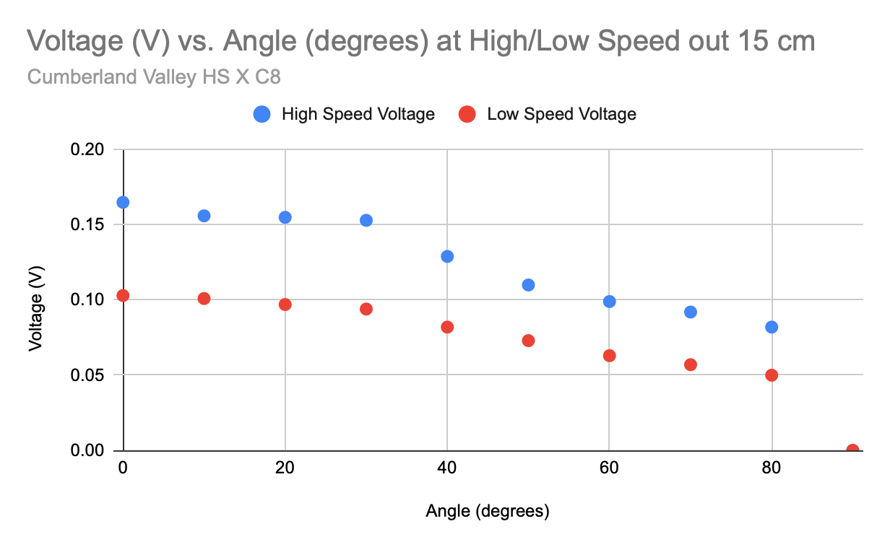

**4.a.iii & 4.a.iv: Graphs & Data Tables (cont.)**

| Out 25 cm | | |
| --- | --- | --- |
| Angle (degrees) | High Speed Voltage | Low Speed Voltage |
| 0 | 0.163 | 0.102 |
| 10 | 0.157 | 0.1 |
| 20 | 0.154 | 0.097 |
| 30 | 0.151 | 0.093 |
| 40 | 0.131 | 0.083 |
| 50 | 0.108 | 0.069 |
| 60 | 0.097 | 0.062 |
| 70 | 0.091 | 0.055 |
| 80 | 0.083 | 0.052 |
| 90 | 0 | 0 |

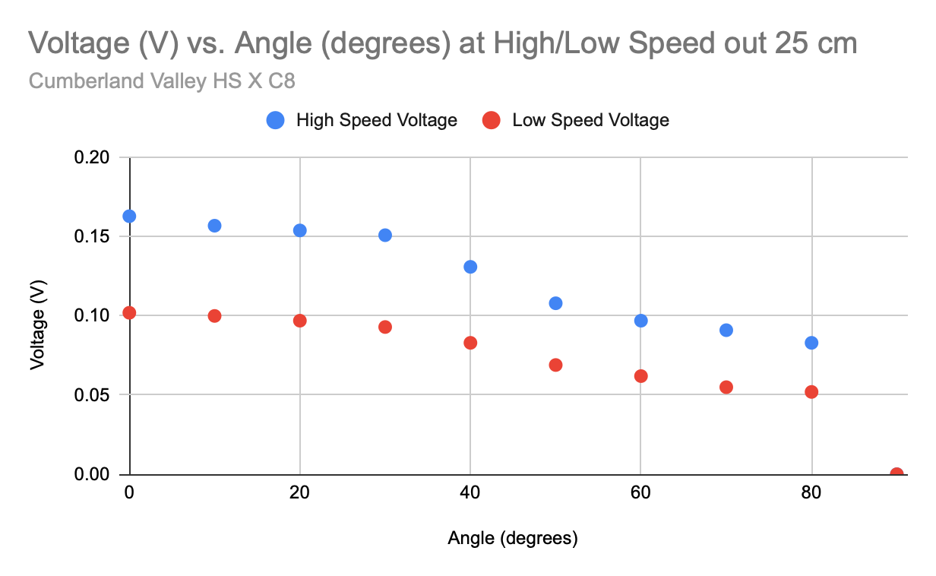

**4.a.iii & 4.a.iv: Graphs & Data Tables (cont.)**

| Out 30 cm | | |
| --- | --- | --- |
| Angle (degrees) | High Speed Voltage | Low Speed Voltage |
| 0 | 0.159 | 0.1 |
| 10 | 0.154 | 0.098 |
| 20 | 0.15 | 0.095 |
| 30 | 0.147 | 0.09 |
| 40 | 0.13 | 0.084 |
| 50 | 0.107 | 0.071 |
| 60 | 0.094 | 0.062 |
| 70 | 0.087 | 0.053 |
| 80 | 0.082 | 0.047 |
| 90 | 0 | 0 |

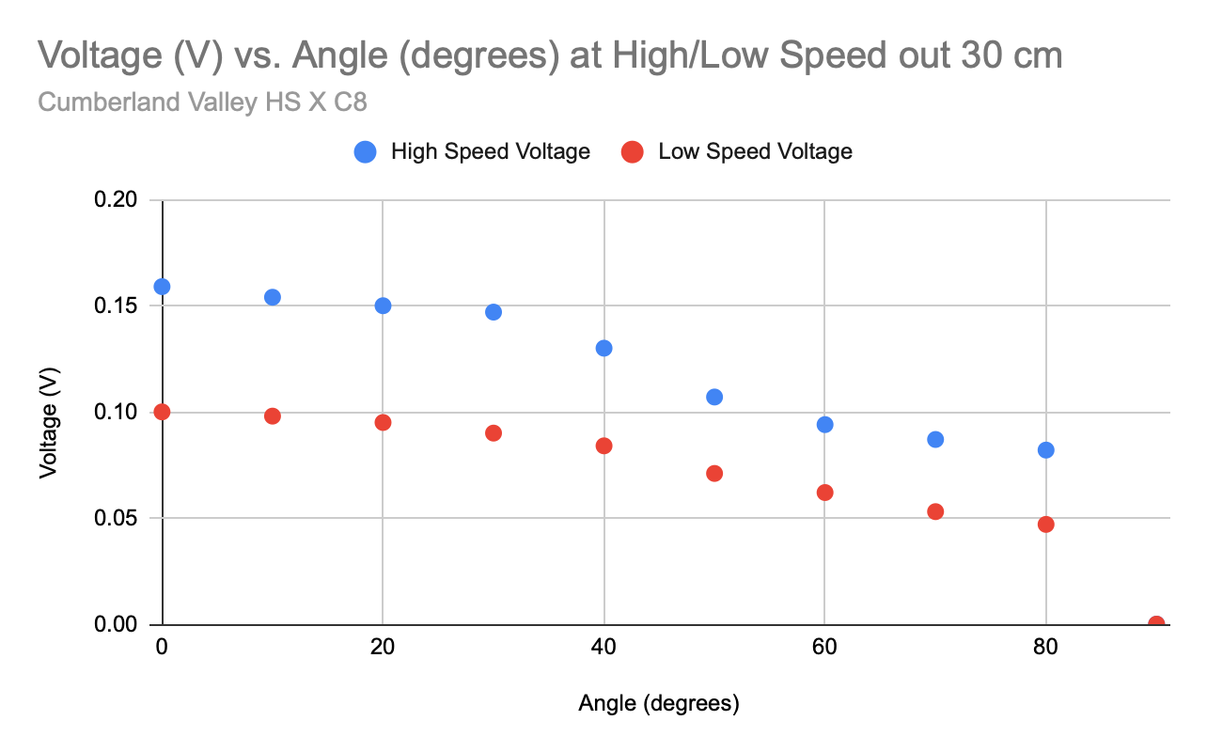

**4.a.iii & 4.a.iv: Graphs & Data Tables (cont.)**

| Out 50 cm | | |
| --- | --- | --- |
| Angle (degrees) | High Speed Voltage | Low Speed Voltage |
| 0 | 0.148 | 0.097 |
| 10 | 0.145 | 0.093 |
| 20 | 0.14 | 0.085 |
| 30 | 0.135 | 0.074 |
| 40 | 0.133 | 0.07 |
| 50 | 0.128 | 0.067 |
| 60 | 0.115 | 0.065 |
| 70 | 0.107 | 0.06 |
| 80 | 0.089 | 0.032 |
| 90 | 0 | 0 |

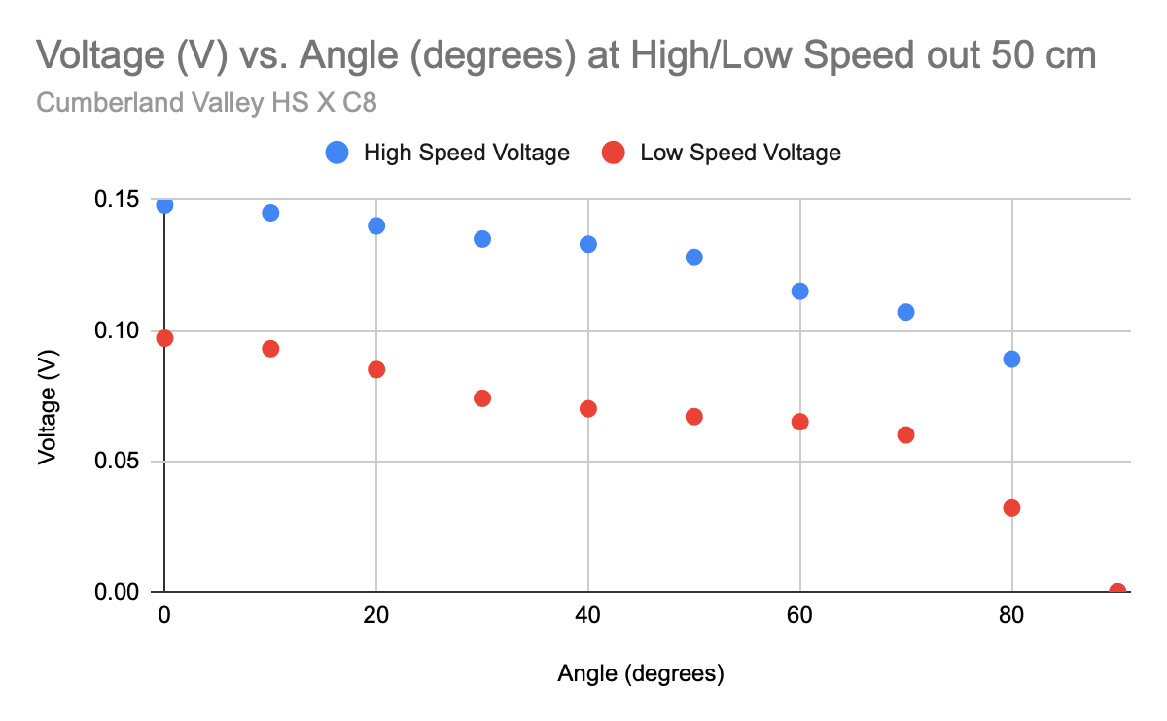

**4.b: 3D Printer**

**i. Info  
Printer : Anycubic Kobra 3D Max  
Software: OnShape CAD Editor**

**Materials: PLA Filament  
ii. Digital File Sources**

**All CAD files produced by the competitors in OnShape and printed as STL files.  
iii. Construction**

**We glued the 3D printed hub to the CD with CA glue and glued the blades to the hub with CA glue  
